**CSD 4203 – Database Programming**

**Student ID : C0930321**

**Student Name : Shreejana Shrestha**

**Assignment # 11**

**----------------------------------------------------------------------------------------------------------------**

# # TASK 1: Tables creation

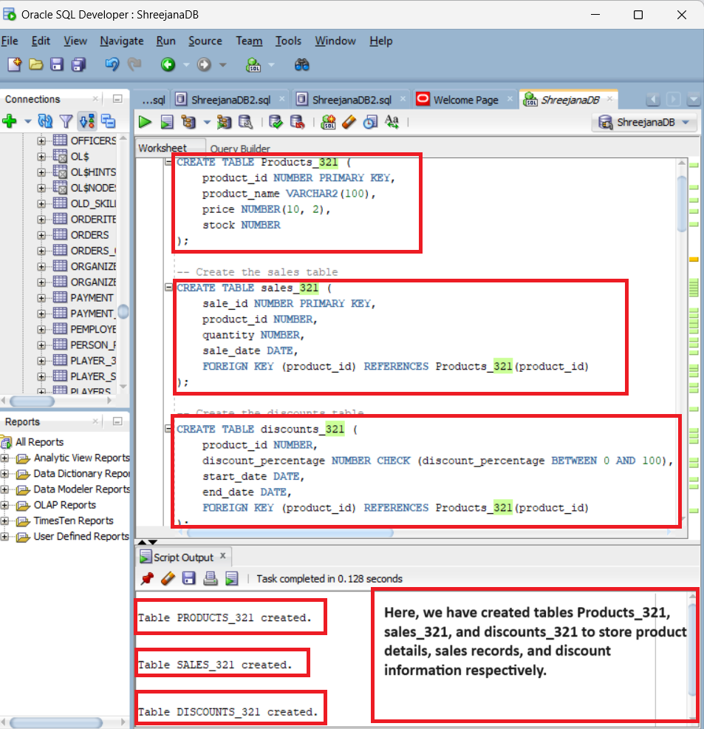

# # TASK 2: Creation of Package (inventory_pkg)

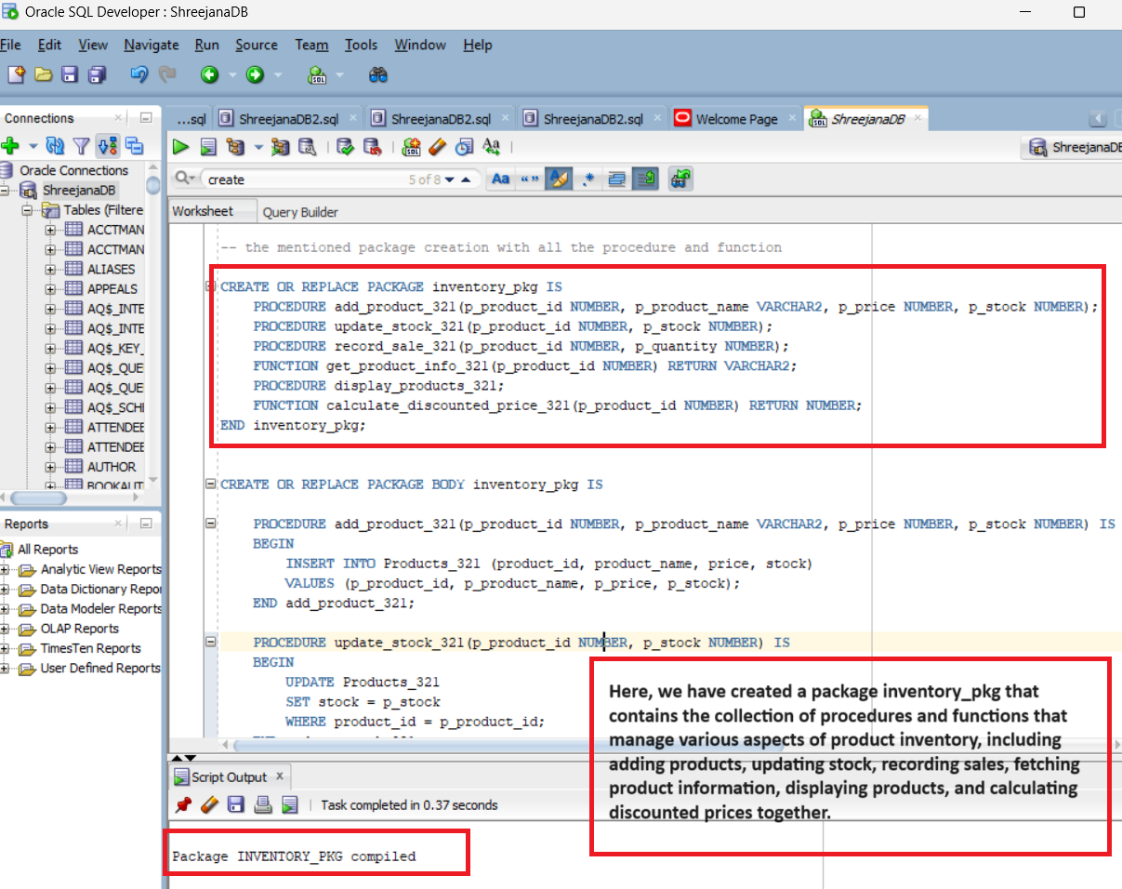

## # package body

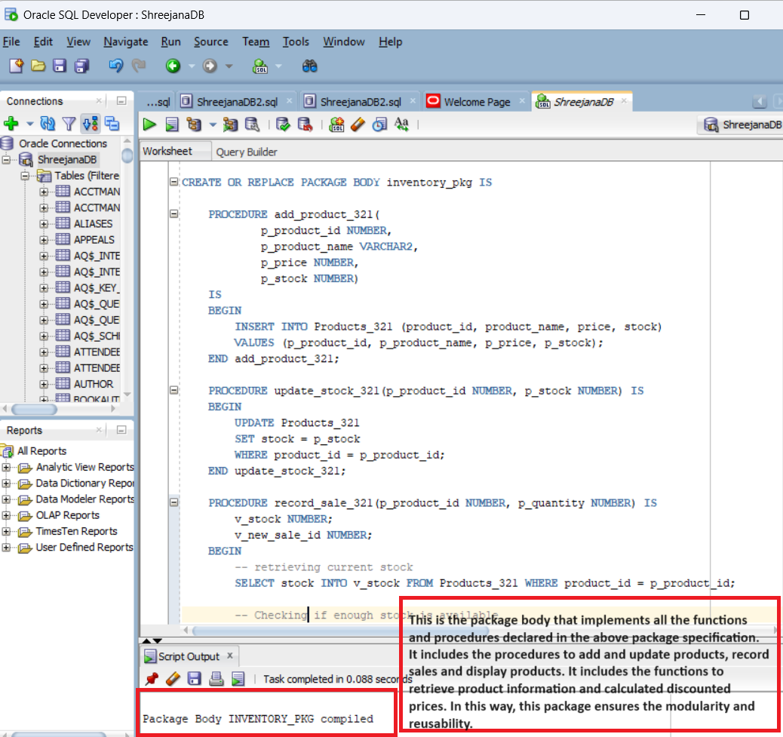

# # TASK 3: Triggers

## 1. Trigger to update the stock

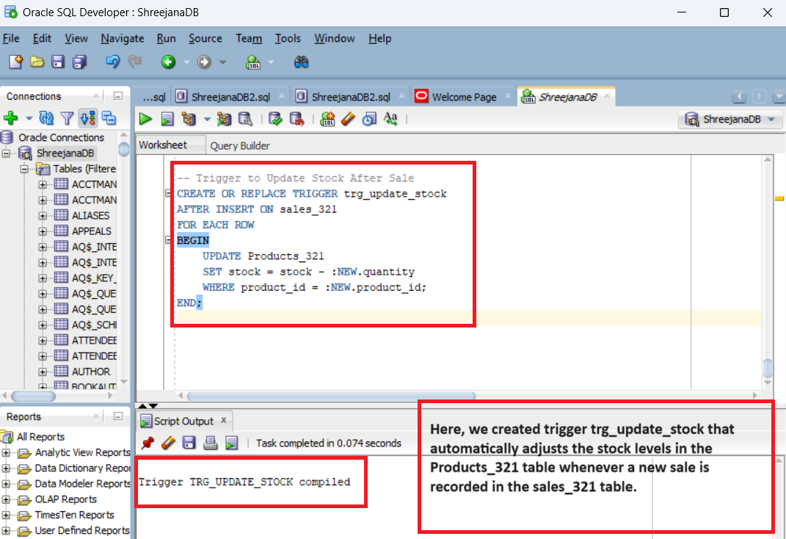

## 2. Trigger to ensure the stock does not drop below zero

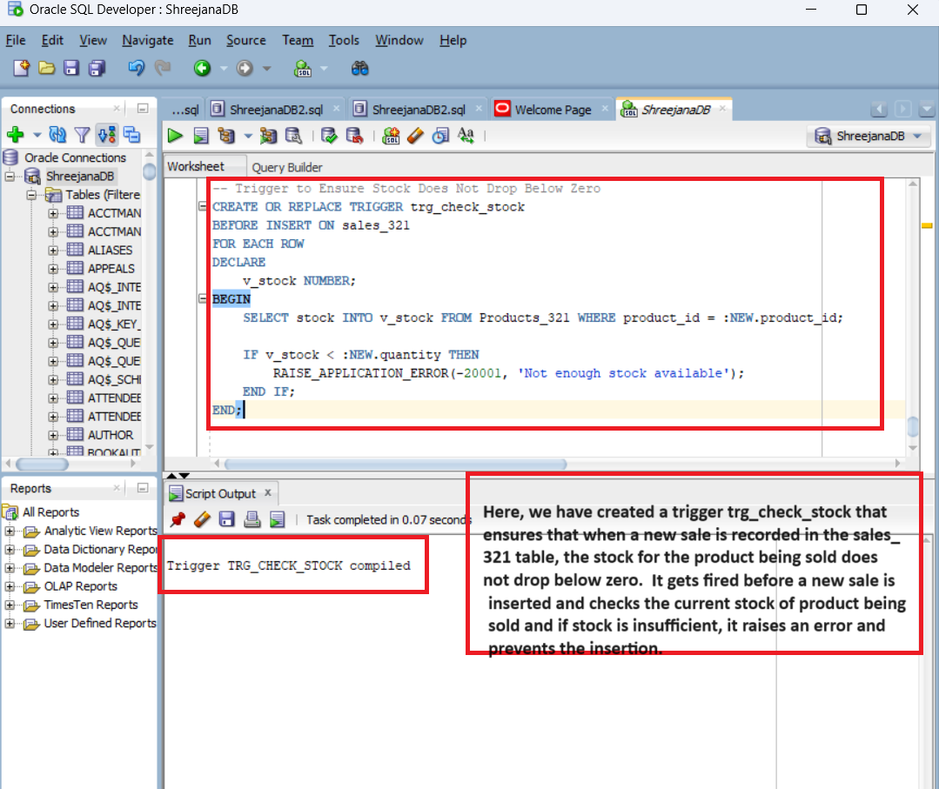

## 3. Trigger to apply discount using calculate_discounted_price_321 function

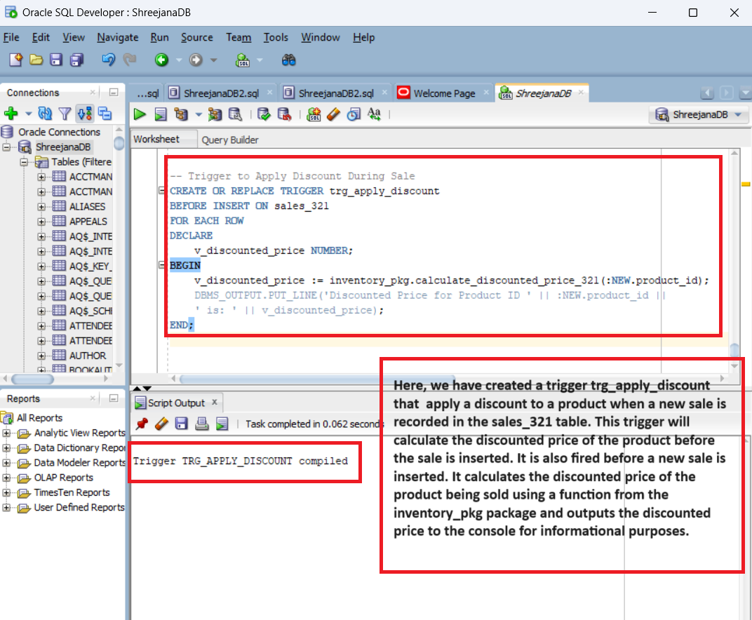

# # Implementation

## # Product adding

## # discounts adding

## # Recording sale

## # Displaying Single Product Info

## # Displaying All Products

